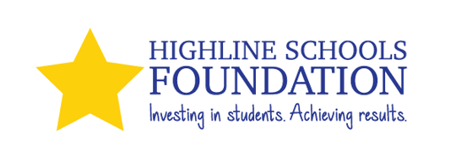
2025-2026 Highline Employee Giving Campaign
Highline Schools Foundation’s mission is to raise funds, gather resources, and build partnerships that make an impact on students' successes in Highline Public Schools. We help our district fulfill its promise—that every student is known by name, strength and need, and graduates prepared
for the future they choose.
Funding for Highline Schools Foundation comes from individuals, businesses, foundations, service groups, events and from generous donations made by district employees.
Please support our work in Highline Public Schools by contributing to the Highline Schools Foundation during the 2025-2026 Employee Giving Campaign, October 6, 2025 - December 15, 2025.
100% of your pledge will be directed to the Foundation. Where Does Your Donation Go?
Basic Needs: We work to provide for students and families basic needs, such as school supplies and backpacks, warm coats and shoes, and access to food resources.
Classrooms & Schools: We support basic and innovative classroom and school needs through our
Excel and Impact Grant programs— We anticipate awarding more than $100,000 in grant funding this year.
College & Career Exploration: We offer substantial college and trade school scholarships,
programming to help students explore career paths and increase graduation rates. In the spring of 2025, we distributed nearly $400,000 in scholarship funding to 61 students graduating in Highline.

Name: Employee #:

Home Address:
City, State, Zip:

Name for recognition:
$
MY TOTAL GIFT:
I wish to make a one-time gift Payroll Deduction
Check/Cash
School/Dept.: Email Address: Check here if you wish your gift to be anonymous
Check No. (Please make check payable to Highline Schools Foundation, and attach check/cash to this form)
Charge my Credit Card (VISA, MasterCard, or American Express)

I wish to make a pledge (payroll deductions and credit card charges will begin January 2024)
Initial here to authorize a payroll deduction of $ per pay period for pay periods

Credit Card #: Billing Address: Signature:

Expiration Date:
CSV:
Date:
Mail this completed form no later than Friday, December 15th, 2025 to: Highline Schools Foundation, 15675 Ambaum Blvd SW, Burien, WA 98166 or through district mail at: M/S: Central Office/Highline Schools Foundation
Highline Schools Foundation is a 501(c)(3) non-profit organization – Tax ID# 91-2020506
All or part of your gift may be tax deductible as a charitable contribution. Please check with your tax advisor.

