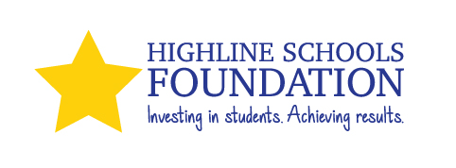

Campaign Email #3 (to send out near the end of the campaign.)

Subject Line: Invest in Students. Achieve Results.

This is the last week of the 2020Employee Giving Campaign. Our goal as a district is to raise $70,000 for Highline Schools Foundation (HSF).

We still have the opportunity to participate in our building’s special activities. [Add information here about any building specific things that you are doing to raise funds and excitement.]

If you want more information about Highline Schools Foundation, you can find it at: www.highlineschoolsfoundation.org.

I’m asking you to give generously through this year’s campaign to support Highline Schools Foundation. We’re trying to make it easier this year as you can now fill out your forms online.

- For payroll deductions to Highline Schools Foundation, click HERE.
- For cash or credit card gifts to Highline Schools Foundation, click HERE.

If you prefer to write a check or give cash, please print out a copy of the form and attach your donation. You can send those to Highline Schools Foundation, 15675 Ambaum Blvd SW, Burien, WA 98166.

Thank you for helping us reach our goal of $70,000 so that we can help invest in students and achieve results.

